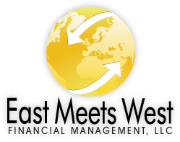

Items Needed for Commercial Loans 08/29/24

- Personal Financial Statement
- 3 Years of Personal and Corporate Tax Returns (2021, 2022, 2023)
- 3 Years of Profit & Loss Statements and Balance Sheets (2022, 2023) AND Year to Date 2024
- Resume(s) of Principals
- Driver’s License(s)
- Equipment Quotes (if needed)
- Deed of Property (if owned)
- Projections/Proforma
- Sources and Uses (if needed)
- Appraisal of Property Owned (if needed)
- Executive Summary (EMW will write this for you)

