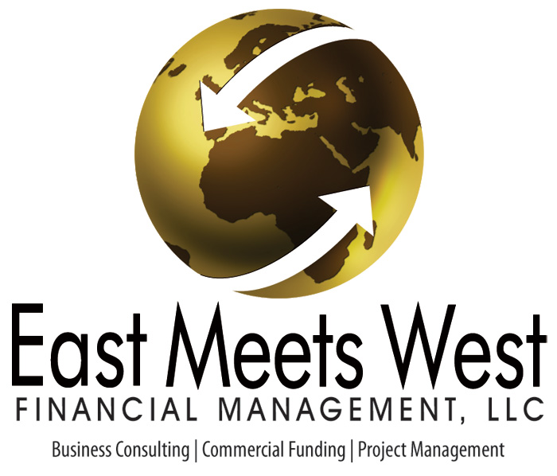

Please complete the questionnaire and provide the following documents in a file format that can be emailed: PDF, Excel, Word for Windows are acceptable file formats.

Additional Documents Needed:

- Business Plan
  - Executive Summary
  - Location
  - The Market
  - Competitive Analysis
  - Sources and Uses of Funds
  - 5 Year Revenue and Expense Pro Forma
  - Financial Forecast Assumptions
  - Resumes of all Principals
  - Articles of Incorporation/
  - Corporate Certificate
  - Feasibility Studies prepared by independent expert if available
  - Current Appraisals if real estate is included and/or purchase agreement

- Additional Documents and/or Supporting Documentation

  - 2 Years Corporate and Personal Tax Returns
  - Personal Financial Statement of all Principals
  - Patents, Government Approvals, Letters of Intent, etc. depending on the project’s scope
  - Independent Construction Estimation if the project is to be built or renovated
  - If the company is currently operating, please send an Income Statement and Balance Sheet
for previous year’s YEAR END Dec. 31, 202__ AND YEAR TO DATE.

1024 Leopard Street Ste. A Corpus Christi, TX 78401 Tel: 361-904-0044
www.emwfinance.com

