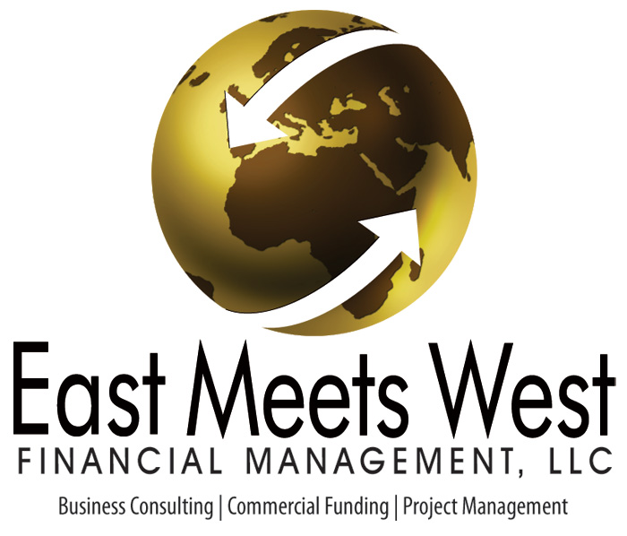

Applicant Information
Please print this form & Send It Securely via Email

Company Name:_________________________________________Tax ID:_________________

Company’s Bank:________________________________________City/State_______________

Principal’s Name:________________________________________________________________

Social Security #________________________________________Date of Birth:_____________

Principal’s Contact Info: Office Phone:______________________Cell Phone:_______________
Fax:_____________________Email:_________________________Website:__________________

Mailing Address:_________________________________________City/St/Zip________________

On a scale of 1 – 10 how would you rate your credit?_____________Credit Score____________

Total Net Worth of Applicants ($USD)_______________________________________

What is the total amount of liquidity (cash/stocks/bonds, etc.) of Borrowers?_______________

Loan Amount Desired:__________________Minimum Net Loan Amt. Required:______________

Desired Interest Rate:________________Length of Terms Requested______________________

Interest Only?_____________________How Long?_______________________

Types of Funding considered or preferred? (Debt, Equity, Joint Venture,etc.):_______________

Use of Funds: Explain the use of the funds and the amount needed, i.e. Acquisition, Development, Construction , Bridge Loan, Permanent Financing, etc.

1._________________________________________________$___________________________

2. _________________________________________________$__________________________

3._________________________________________________ $____________________________

4.__________________________________________________$____________________________
1024 Leopard St. Ste. A Corpus Christi, TX 78401 Tel: 361-904-0044
1 of 3

Time Constraints on Loan:__________________________________________________________

Reason:_________________________________________________________________________

How much of their own money have borrowers invested in the project?____________________

Please describe, if any, any current revenue generation from the project:__________________

When do you expect the project to be generating revenue?______________________________

Does Applicant have reserves to pay for 3rd party reports, appraisals & due diligence? (YES or NO)_________________________

Will the applicant personally guarantee the repayment of the loan? (YES or NO)_____________

Are any current or back taxes owed? Please describe if yes._____________________________

Have all regulatory or government approvals been obtained? (Patents, environmental studies, FDA approval, etc) ________________________________________________________________

Any financial bond, letter of credit or bank guaranty on the project? Describe if yes.

Any funds available now? Please describe if yes.
________________________________________________________________________________________________________________________________________________________________________________________________________________________________________________

How long has company been seeking financing?_____________________________________

Is the applicant engaged with any other funding sources at this time? Describe:
________________________________________________________________________________________________________________________________________________________________________________________________________________________________________________________________________________________________________________________________

Describe any credit issues surrounding the project.
________________________________________________________________________________________________________________________________________________________________________________________________________________________________________________________________________________________________________________________________

2 of 3

Assets Owned that may be used as collateral pledge towards the project, check if applicable:

_________Equipment ________________Stocks/Bonds ______________Real Estate

Encumbered Assets Available as Collateral:

Type Location Encumbered Amt. Total

________________________________________________________________________________________________________________________________________________________________________________________________________________________________________________________________________________________________________________________________________________________________________________________________________________

Has a financing request for this project been turned down previously? This info is critical in determining issues to be overcome by our representatives.

By Whom and Reasons:________________________________________________________________________________________________________________________________________________________________________________________________________________________________________

Are you currently working with any lender, consultant or broker on this transaction? If yes, who?________________________________________________________________________
______________________________________________________________________________

I authorize EMW Financial Management,, LLC to make inquiries as necessary to verify the accuracy of my statements and determine my creditworthiness. I certify the above statements and those contained in the attachments to be true and accurate as of the stated date(s).

Borrower’s Signature:___________________________________Date:______________________

3 of 3

